Mrs. Blouin / Iroquois Ridge High School
Name: ________________________________________________
TECHNOLOGICAL DESIGN

Tips on how to be a sketch god!
(or at least get you close!):
From DesignSojourn.com

1) Know how you draw
Do you draw lines by moving your wrist, elbow or shoulder? There is really no right or wrong way to draw, though most purist advice to use draw from the shoulder. The reason for this is really about the type of sketch you want to create.
Wrist action encourages “tight” sketches and very good for a controlled sketch style. Drawing from the shoulder gives you a more sketchy and loose lines as you are literally firing off the lines. If you want the create that Emotion sketch this is the technique to use, but frankly this style requires a lot of practice in controlling your lines. Drawing from the elbow gives you the middle ground. At the end of the day pick the technique that you are most comfortable with.

2) Practice
When I started my design career, I drew everything every day. I refused to use tracing paper, rulers or erasers. If you want to improve your sketching skills you need to invest time and effort. Practice drawing buttons, perspective cubes, and horizontal or vertical lines. I have pages full of horizontal lines of at least 15cm long.

3) Understand the concept of varying line weights
One of the good tricks of sketching is to use different line weights or thicknesses. Basically you use thicker lines for edges further from the eye, and thin or dotted lines for edges closer to you.

4) Use intentionally sketchy lines by keeping your arm loose
In other words lines don’t end at the junction, keep them going and shoot them off. Creating loose sketchy looking lines is really a technique that can be easily learned.

5) Redraw your sketches and present them in a better light
I have seen many portfolios of designers with a few years of experience still include sketches from their school days. Now if you have been following my advice your sketching ability would have improved, so re-draw those old and ugly sketches, there is nothing and no-one saying you should not. This time, perhaps, take the opportunity to refine it to the level that you are happy with it.
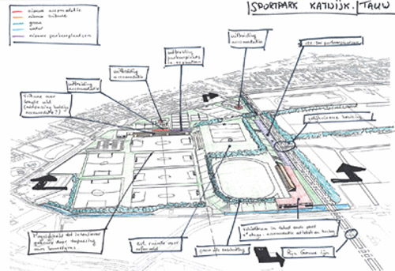

6) Use callouts with cool handwriting
I don’t think I have to say much more about this, but the fact that annotations at strategic places does makes a sketch look cool. Oh and if your handwriting is not too good, I do suggest you pick up a book on drafting and practice.

7) Use the photocopier to save redrawing a good part
I only recommend this if your sketching ability is fairly good or if you are rushed for time. Otherwise redraw it from scratch. Photocopiers work great with Liquid Paper or Correction Fluid.

8) Draw big, but show it small
Actually a great presentation trick is to scan in your images, touch up the lines with Photoshop, and present them in a collage. Such a presentation strategy makes average sketches look good, and good sketches look GREAT!

9) Draw small, but show it big
If you have still a tough time sketching from your elbow or shoulder and if your line control is still not the best, what I suggest is to draw a thumbnail and blow it up on a photocopier or scanner. This way you would have an underlay to redraw your sketch with the same look and feel but with thinner lines.

10) Use layouts created from 2D or 3D software
Talking about the use of an underlay, use this time tested trick to create your sketches with a correct perspective, or for you to create a 2D orthographic sketch in proportion.

11) Draw with a pen
From what I’ve been told, sketching with a pen, instead of a pencil, is really about losing the ability to erase your lines, or erasing your mistakes. The idea here is that drawing with a pen forces you to think before your draw, and as you cannot erase your work, and you will then draw with a determined solution in mind. In other words, drawing with a pen trains your mind to think the design solution through before you actually put it on paper. It will make you a much better designer.
The other reason is that, you stop being precious with your sketches and drawings, i.e. you draw and if it does not look good, you don’t get to erase and draw over, but you throw your drawings away and start fresh. This re-setting and starting from scratch seems to help make you a better designer, so the say!

