Mrs. Blouin / Iroquois Ridge High School
Name: ________________________________________________
TECHNOLOGICAL DESIGN

Tips to Sketching
from: DesignSojourn.com
One of the greatly misunderstood concepts of design is that a good designer must be a good sketcher.
Sketching can be self-taught and doesn't need to be perfected in order to succeed. There have been famous designers who have created terrible sketches but end up with great designs, and great sketchers that are hopeless designers.
Essentially you would only need to draw or sketch well enough to communicate your concept on paper without you having to explain what it is. You don’t have to win the beauty contest, but you WILL have to do well enough so that a fellow designer (or if you want it to be tougher on yourself, a non-designer) can understand what you are attempting to communicate. Notice the key word here? It’s not drawing, draw, design, or sketch, it’s communicate. A good sketch communicates an idea clearly and succinctly.
Sketching is also one part of the design process that makes up a successful design. Strong understanding in proportions, colors, and manufacturing processes are other important elements that can make or break a design. So don’t despair if your sketching ability, at this time, is not up to par, as you will have a chance to refine it in the downstream design process.

Thumbnail or Napkin sketchSource: Core77
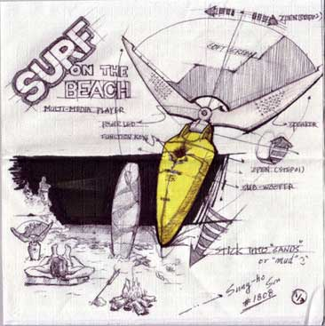
A thumbnail sketch is a very basic sketch that has an almost child like quality to it. This type of sketch is mainly about getting your ideas down on paper as quickly as possible without too much care about proportions and beauty. It’s often pretty rough focusing only on the key “big” idea. Thumbnails sketches are often the most frequently used sketch technique used to communicate ideas.

