Mrs. Blouin / Iroquois Ridge High School
Name: ________________________________________________
TECHNOLOGICAL DESIGN

Assignment - 1 and 2 Point Perspective of Commercial Buildings

Part - A
You are to make a 'good' 1-point perspective drawing of the following street view:
(tip - divide the paper into quarters to help with ensuring proper proportions).
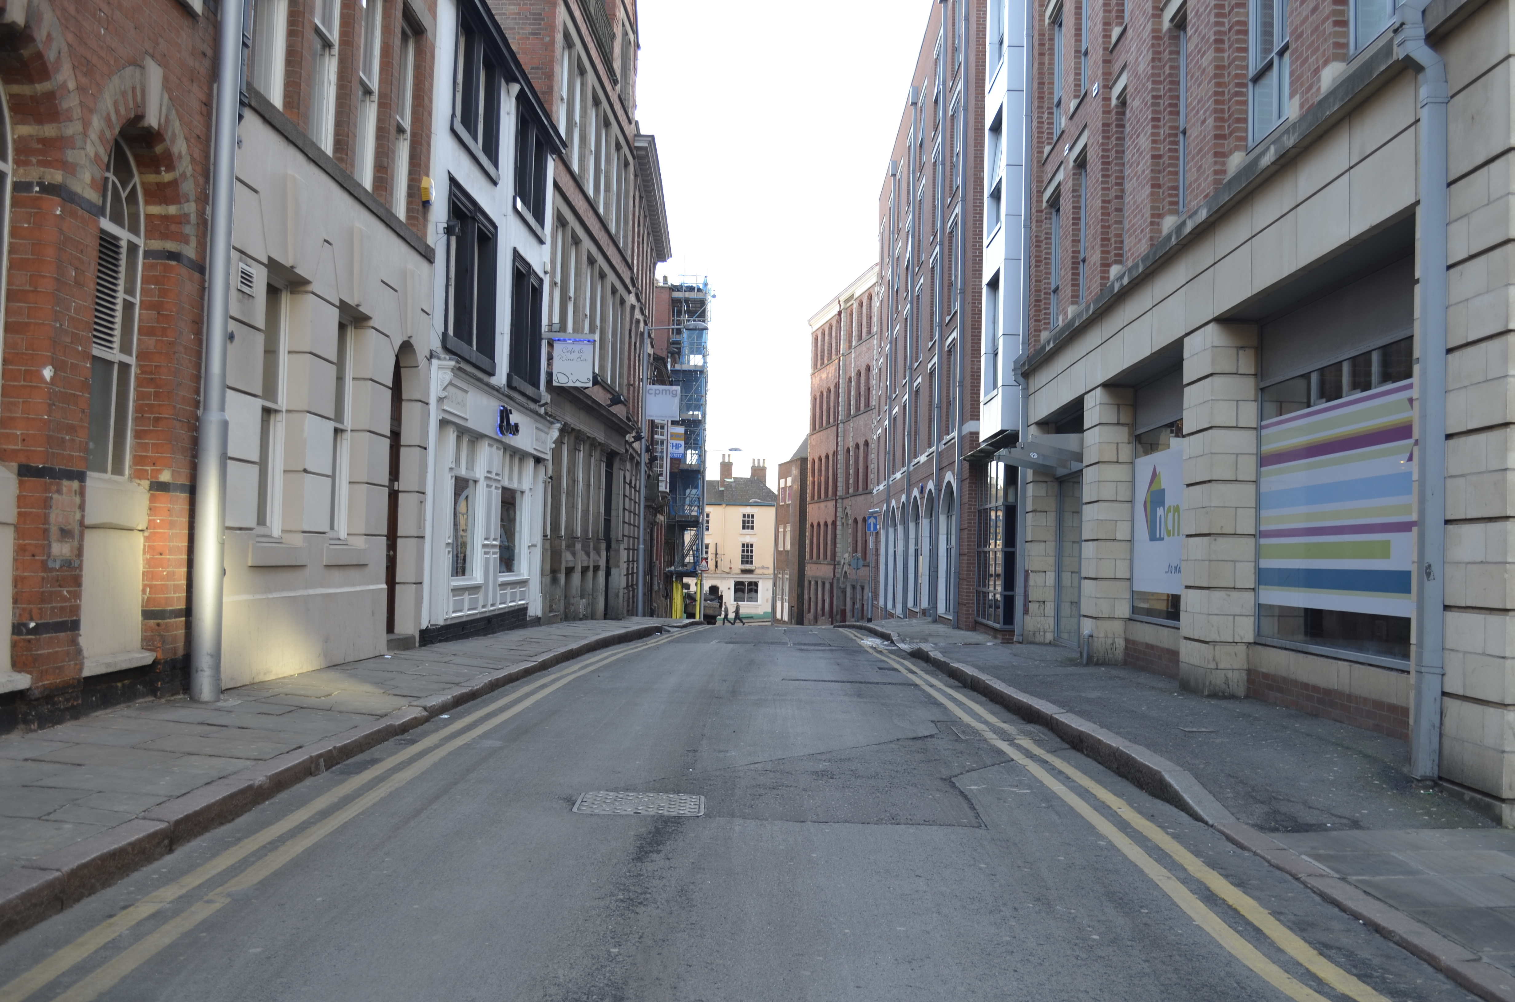

Part B
You are to make a 'good' 1-point perspective drawing of the following street view:
(tip - divide the paper into quarters to help with ensuring proper proportions).

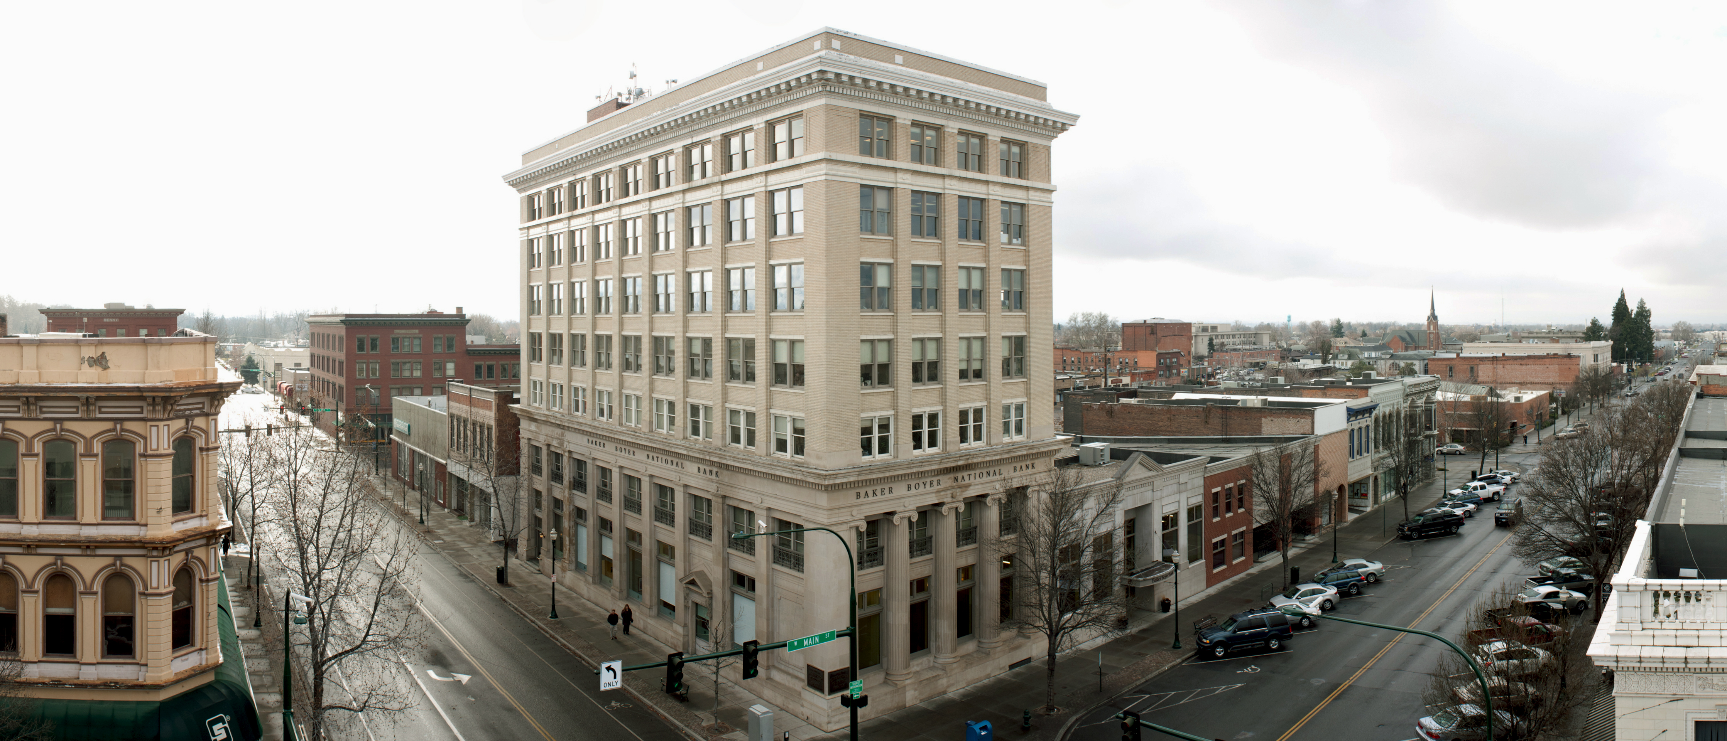

You will be evaluated as follows:
CATEGORY | LEVEL 1  12 13 | LEVEL 2  14 15 | LEVEL 3  16 17 | LEVEL 4  18 19 20
Sketches  (Thinking) | The sketches have many defects or are poor quality. | The sketches have some defects, but still portray the object. | Good choices in line-weights and angles that best illustrate the chosen topics. Drawings are defect-free but may contain a few unwanted features. | Superb choices in line-weights and angles that best illustrate the object. Drawings are free from distracting elements.
1 point perspective drawing  (Application) | Lines merge but with much room for improvement. | Lines generally at the VP. | Lines merge at the VP with few flaws in the drawing. | Lines merge seamlessly at the VP. There are no flaws in the drawing.
2 point perspective drawing  (Application) | Lines generally merge towards the VPs. There are multiple flaws in the drawing. | Lines merge at both VPs. There are flaws in the drawing. | Lines merge well at both VPs. There are generally no flaws in the drawing. | Lines merge seamlessly at both VPs. There are no flaws in the drawing.
Use of Time | Used time poorly (as shown by observation by teacher and/or documentation of progress in journal) in spite of several reminders to do so. | Used time well (as shown by observation by teacher and documentation of progress in journal), but required reminders on one or more occasions to do so. | Used time well during most class periods (as shown by observation by teacher, and documentation of progress in journal) with no reminders. | Used time well during each class period (as shown by observation by teacher, and documentation of progress in journal) with no reminders.
File type and size  (Knowledge) | Only a few of the requirements have been met. | Many present. Some important components missing. | Generally all elements are present. | All elements are present.

