Mrs. Blouin / Iroquois Ridge High School
Name: ________________________________________________
TECHNOLOGICAL DESIGN

Who lives there?
Directions: based on looking at the photo of the house below, write 3 complete sentences about the people who might live there. What are their lives like? What is their lifestyle? What kinds of things do they prefer? What are their jobs? What does their house say about them?
- Traditional Home

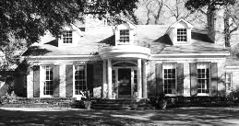

- Ultramodern Home

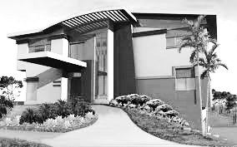

- Small Bungalow
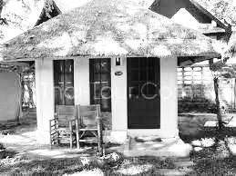

- Log Cabin with Sod Roof
