What's in a house plan?
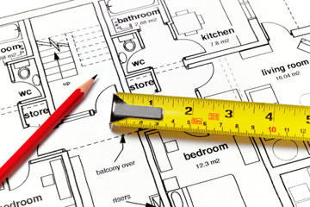

The pages of a house plan, known as a "drawing set," tell a contractor everything he or she needs to know to properly stick your dream home on top of a bare piece of land. Not only do these plans define a home's footprint and how it will eventually look to the naked eye, but they also describe a home's inner plumbing and electrical specs and even the materials and finishes that will complete your home.
A standard house plan includes the following sections (some are one page and others are multiple pages of the plan):
- Cover sheet -- shows an artist's sketch of the house's finished exterior
- Foundation plan -- your house's footprint, including any areas that require excavation
- Floor plans -- a page per floor showing rooms, walls, doors and windows, and additional suggestions for electrical outlets and fixtures
- Interior elevations -- your vertical wall plans, including plans for built-in cupboards, bookshelves and other features whose construction the contractor will oversee
- Roof plan -- an exterior view, showing the peaks, slopes and outline of your roof
- Exterior elevations -- a view of each of your house's four sides, showing exact measurements for each side, along with the materials and details.
- Wall details -- What's inside your walls? This section of the house plan shows insulation details and names the materials used in flooring and roofing.
- Structural plan -- plans for your house's important connections including trusses and second floor framing

So, what's found within the pages of these sections?

Interpreting House Plans
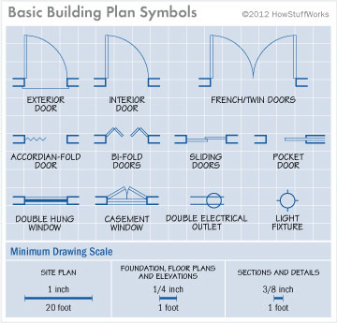

Other than the artist's rendering of the exterior of the house, most of a house plan won't look much like a house. Instead, it's filled with standardized symbols that represent parts of your house. When a builder looks at house plans, he sees doors, windows, walls and electrical outlets, represented by symbols. Once you understand the symbols on a house plan, you'll see the house the way he does. Here are some basics on reading plans:

- House plans are drawn to scale, meaning that when you multiply the lengths of the lines in your plans by a previously determined number, you wind up with their length in real life. There are no absolute scales used for all house plans, but commonly the minimum scale for a site plan is 1 inch equals 20 feet. For foundation, floor plans and elevations it's 1/4 of an inch equals 1 foot, and for sections and details 3/8 of an inch equals 1 foot [source: National Council of Building Designer Certification]. Because a plan is drawn to scale, it shows everything exactly as it will be built relative to everything else around it -- even though it's obviously much smaller than your house will be. For example, this means that an exterior wall that looks thicker than an interior wall on your plans will, in fact, be thicker in real life. To get a feel for scale, look at one of the floor plans and calculate the real-life measurements of a major room. Then compare those measurements to rooms in the house where you live now. Imagine the remaining rooms, hallways and traffic flow in your plan relative to this room you've measured out, as well, to help you get a feel for your future home.
- Nearly every feature commonly seen in houses is represented by a standardized symbol on a plan. For example, there are nine common symbols to represent various types of doors, ranging from French, to swinging, to bi-fold, to accordion [source: eHousePlans.com]. Search online or work with your architect or builder to understand these many symbols (and see our handy guide above). It's worth working to understand at least the symbols for doors, windows and electrical outlets.
- Specifications: In addition to showing what your house will look like and how big each room will be, it also will describe how these parts will be made and what they should be made of. Your specifications sheet describes fixtures, appliances, materials and other homeowner preferences. Even if you buy premade house plans, you may still have significant wiggle room to change its specs. Consider picking wallpaper stains, paints, fixtures, hardware and other materials [source: Byoh.com].

Tips for Reading House Plans

Whether you're looking them over with your architect or checking out house plans online, it's nice to know a few things about homes to help you understand the plans and decide whether they represent what you want in a house.

For example, did you know that style of homes are defined by how they're laid out as well as their architectural features? A colonial home generally has a central hallway with square rooms on either side and two larger rooms in the back. A ranch home is "L"-shaped, one-story, with the bedrooms grouped on one side of the house. A Victorian house is defined by features like fish-scale shingles and bay windows. And a Cape Cod home has two bedrooms upstairs with sloped ceilings [source: TheHouseDesigners.com]. By learning about the various styles of homes, you'll be able to identify their features on a house plan, which will help you be able to picture the house in your own mind.

In addition to evaluating the layout of the house, take a long hard look at the materials and finishes. Weigh your desire for granite countertops and energy efficient appliances with your desire for a big footprint. Those nickel and dime features can take you over budget quickly. Also, when looking at the materials and techniques listed in your plan, remember that green design can pay off in the long run, but that green techniques may not be appropriate for all climates [source: HomeBuildingSmart.com].

Overall, remember that house plans can be changed -- and it's better to troubleshoot on paper than change the design during the building process, or worse, realize once the house is built that you don't like it. Work with your architect and/or builder to fully understand your plans, then adjust them as needed. Does your modern life require more electrical outlets in the office? Add them. Does your site require the plans be flipped to their mirror image? Flip 'em. Will little kids running through a tight hallway require pocket instead of swinging doors? Change it.
In short, the ideal home isn't necessarily the biggest or prettiest -- it's the one that best fits your life. Think about what's important to you, and then work to make sure your priorities are represented on paper.

http://home.howstuffworks.com/home-improvement/construction/planning/how-to-read-house-plans1.htm

