Mrs. Blouin / Iroquois Ridge High School
Name: ________________________________________________
TECHNOLOGICAL DESIGN

Summative – Store Redesign
This project requires you to complete multiple phases, with each phase building on the previous one. You will be creating your own store design and layout.

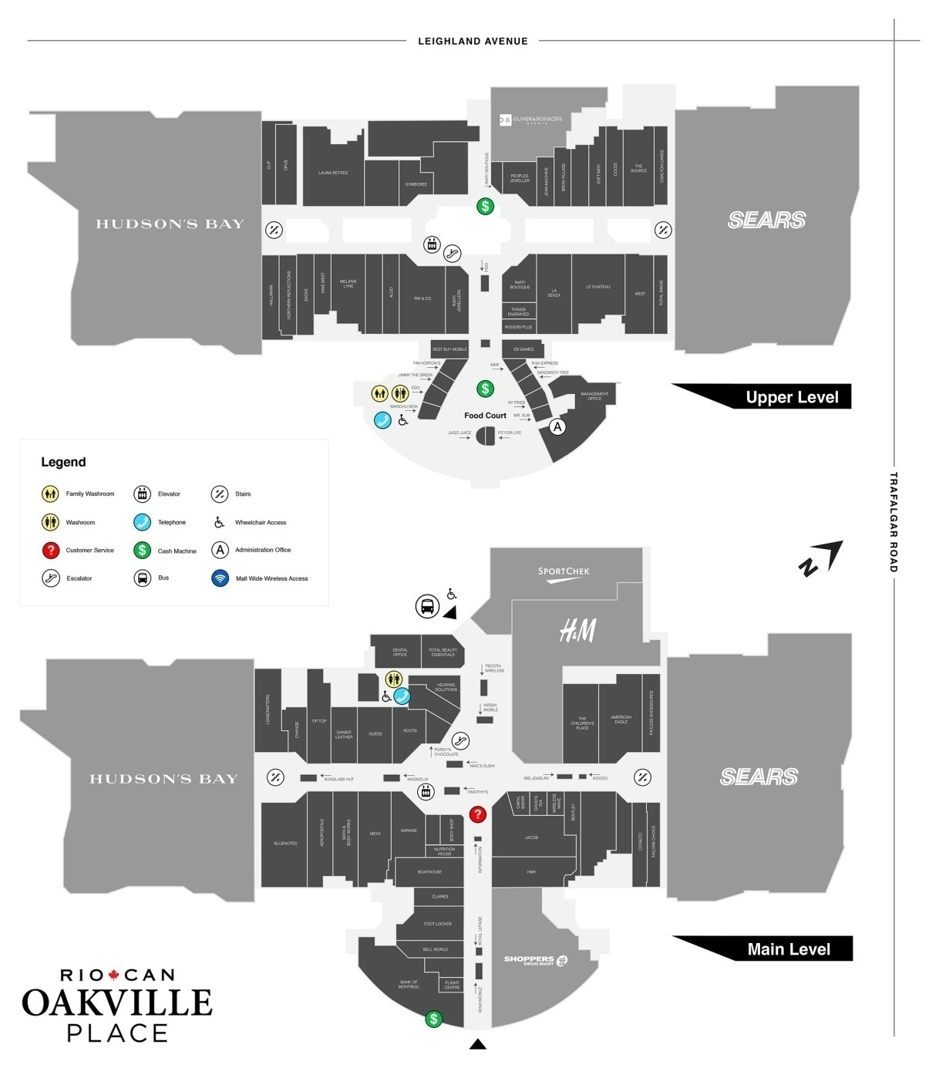
Phase 1 - Visual Merchandising Mall Assignment
Put all content into a PowerPoint /Prezi presentation

Go to Oakville Place and choose a store to evaluate their visual merchandising.

Store Name: ________________________________ Student: ______________________________________

- What is the image you believe this company is trying to portray?
(ex. target audience, retail style, mood, feeling, etc)
- How is the store laid out? What are the traffic patterns?
(ex. where is the cash desk?, How is the merchandise being displayed?, When a customer walks around the store, what do they see 1st, then to the right/left, back of the store….. etc)
- Record the merchandise in the window. If there is no window display, what merchandise is used for an interior display?

- On a scale of 1-5, 5 being the best, rate whether the following elements conform to the over desired effect and mention the effect or image type each element portrays.

Storefront | Rating | Effect/ Image/ Description
Store’s Exterior
Signs
Colours
Entrances
(doors, walkway)
Window Displays
Store’s Interiors
Floor Coverings
Lighting
Colour
Store Fixtures / Displays
Width of Aisles
The Store’s Interior Matches the Corporate Images / Identity

Phase 2 - Creating Your Store Design
Put all content into a PowerPoint /Prezi presentation

Must use element and principles of design when giving any rational for function and design.

- Create a company name
- Decide what products you will sell
- Decide where in Oakville Place your store will be located (Pick a current store that you would like to replace). And why?
- Provide a DESIGN BOOK including a list of furniture / flooring / lighting / mannequins and any other features that will be inside your store. Find photos from the internet to display the items of your store. (ADD THIS TO YOUR POWERPOINT OR PREZI)

- Describe your choice of color palate, furniture style, walls, floors, window treatment, and a rationale for each.

- How is the store laid out? What are the traffic patterns?
(ex. where will the cash desk be?, How will your merchandise be displayed?, When a customer walks around the store, what do they see 1st, then to the right/left, back of the store….. etc)

Phase 3 - Designing Your Retail Store Floor Plan Sketch
Must be either a hand drawn floor plan, or Floorstyler.com floor plan. Add floor plan design into your PowerPoint or Prezi Presentation.

In order to create a detailed floor plan sketch you will need the following items in your store.

- Dimensions – 25’ x 94’
- Customer walk way path
- A cash desk
- Emergency exit doors (usually in the back of the store)
- Fixtures
- Feature Table or fixtures
- Window display area
- Change rooms (male and female)
- Doorway(single [if using a single door – read #10] or double) with window display

All areas of your store MUST follow the guidelines of the “Town of Oakville – 2008 guidelines for design of accessible facilities.

- All doorways must be a minimum of 36” wide
- Around all door openings and aisles you will show proper amount of space needed to maneuver a wheelchair.

Example: Projects from Concept to Completion
http://storeplanningonline.com/pharmacy-morphs.html

Phase 4 - Designing Your Retail Store using Google Sketchup

- Provide a Google Sketchup plan of 25’ x 94’
- Must have store fixtures and details

Oral Presentation

The oral presentation will demonstrate the ability to present, communicate, and defend the design of the room. The oral presentation has four parts: research on current store, introduction to your own design, discussion of the design, and a summary.

The introduction identifies the main features of the design and emphasizes how the design satisfies the client’s needs. The discussion section presents the designer’s detailed analysis of the design (using elements and principles of design). The summary section presents an overview of the entire design.

 | LEVEL 1 | LEVEL 2 | LEVEL 3 | LEVEL 4
PHASE 1  Assessing a current store  COMMUNICATION  KNOWLEDGE | Research is incomplete and missing valuable information. | Research is limited. | Research is informative and allows for development of proper structure. | Research is highly detailed. Descriptive informative allows for development of proper structure.
PHASE 2  Design Write-Up  THINKING  COMMUNICATION | Project details are incomplete and missing valuable information.  Appropriate  design principles in four rationales | Project details are limited.  Appropriate  design principles in five rationales | Project details are informative and allows for development of proper structure.  Appropriate  design principles in six rationales | Project details are highly detailed. Descriptive informative allows for development of proper structure.  Appropriate  design principles used in all rationales
Design Book  THINKING | Project details are limited. | Project details are limited in descriptions. | Project details are descriptive and relevant. | Project details are very descriptive and relevant.
PHASE 3  Floorplan Sketch  APPLICATION | Information displayed needs more detail. There are minor to no flaws in the drawing. | Detailed information displayed. There are minor to no flaws in the drawing. | Somewhat detailed information displayed. There are minor flaws in the drawing. | Detailed information displayed. There are no flaws in the drawing.
PHASE 4  Google SketchUp  APPLICATION | Digital plan is incomplete or incorrect. | Digital plan limited in creation and/or missing components. | Digital plan is detailed. There are no missing components. | Digital plan is highly detailed. All components are listed.
PRESENTATION  COMMUNICATION | Student’s PREZI, or PowerPoint presentation is missing details from the project and is somewhat engaging. | Student’s PREZI, or PowerPoint presentation has most details from the project and is engaging. | Student’s PREZI, or PowerPoint presentation has all details from the project and is engaging. | Student’s PREZI, or PowerPoint presentation has all details from the project and is highly engaging.
Use of Time | Used time poorly (as shown by observation by teacher and/or documentation of progress in journal) in spite of several reminders to do so. | Used time well (as shown by observation by teacher and documentation of progress in journal), but required reminders on one or more occasions to do so. | Used time well during most class periods (as shown by observation by teacher, and documentation of progress in journal) with no reminders. | Used time well during each class period (as shown by observation by teacher, and documentation of progress in journal) with no reminders.

